The Globalizing K-Pop Project: Sentiment Analysis of Global Fandoms on Social Media
Steps involved in analysing sentiment towards K-Pop:
- Data Collection
- Reddit: Collect comments from Reddit focusing on reviews related to K-pop.
- Web Scraping: Using PRAW (Python Reddit API Wrapper) for web scraping.
Targeted K-Pop Music:
  - Bangtan Boys (BTS)
  - BlackPink
  - SF9
  - Kpop_uncensored
  - K-pop

- Data Preprocessing
- Cleaning: Remove irrelevant information such as HTML tags, punctuation, and stop words (e.g., "the," "a").
- Language Processing: Depending on the language of the website (English or local languages), apply Natural Language Processing (NLP) techniques like stemming or lemmatization using libraries such as NLTK or spaCy.
- Sentiment Labelling: Manually annotate a small portion of the data (reviews) with sentiment labels for validation.

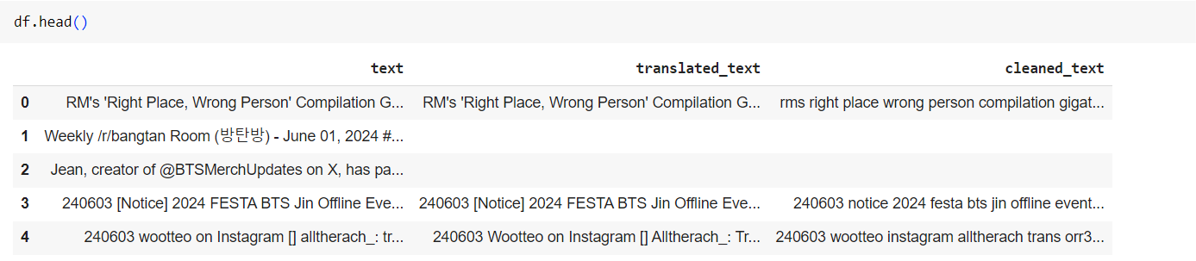
Fig 1. Preview of the dataset collected

- Text Representation
- TF-IDF: Calculate the Term Frequency-Inverse Document Frequency to weigh the importance of words.
- Word2Vec (CBOW): Generate dense vector representations of words using the Continuous Bag of Words (CBOW) model to capture semantic meaning and relationships.
- Topic Modelling
Apply topic modelling techniques such as Latent Semantic Analysis (LSA) and Latent Dirichlet Allocation (LDA).
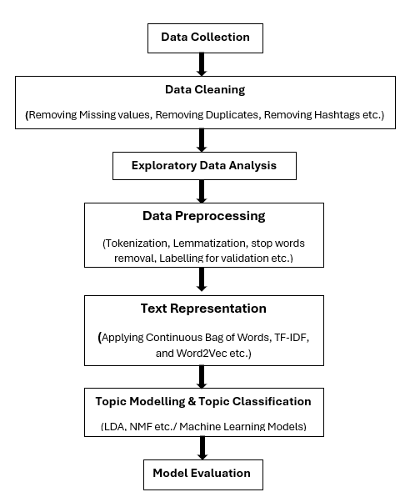
Fig 2. Research Methodology

- Topic Classification
- Labelling and Encoding: Assign and encode topic labels into categories such as emotional, informational, instrumental, and appraisal.
- Text Vectorization: Transform text data into numerical representations using TF-IDF.
- Model Training: Train a classification model using algorithms like Naive Bayes, SVM (Support Vector Machine), etc.

- Evaluation
- Coherence Score: Measure the semantic coherence of the topics. High coherence scores indicate more interpretable topics.
- Human Judgment: Manually evaluate the topics for interpretability and relevance.
- Topic Diversity: Assess the diversity of the topics to ensure that the model captures a wide range of themes.
- Visualization: Use tools like pyLDAvis to visualize the topics and their distributions, helping to qualitatively assess the model.
- Analysis and Insights
- Comparison: Compare and contrast the study results with prior research on social support in other online communities.
- Insights: Present the findings of the analysis, including:
  - Identified types of social support behaviours among global K-pop fans.
  - Comparisons with other online communities.
  - Insights gained from the study.

- Results Interpretation
Interpret the results to gain actionable insights about the sentiment and social support behaviours within K-pop fandoms, and how they compare to other online communities.
Fig 3. Research methodology from some research paper

